OIL CONDITION MONITORING REPORT SLNS SAYURA

ENGINE PARTICULARS (Information provided by the customer)
 | Stbd Main Engine (No.01)
Make : | SEMT PIELSTICK
Model : | 16 PA 6V 280
Sr.No’s: | 8291
Sampling Date | 20 Dec 24
Sampling point : | Lube oil sump
Sampling Method : | Extraction
Type of Lubricant : | Shell Gadinia S3 40
System Capacity : | 1400 Ltrs

RUNNING HRS DETAILS(Information provided by the customer)
 | Stbd Main Engine
Sample ID | M009277
Oil Running Hours | 500.00
Total Running Hours of the Machinery | 47494.40

ANALYSIS RESULTS
Basic Properties
 | ASTM Method | Fresh Oil  (As per OEM data sheet) | Uncertainty | Stbd Main Engine  (S/I- M009277)
Viscosity @ 40ºC (cSt) | ASTM D 445 | 128.00 | 0.018 Cst | 124.71
Viscosity @ 100ºC (cSt) | ASTM D 445 | 13.70 | 0.018 Cst | 13.76
Viscosity Index | ASTM D2270 | 103 | N/A | 107.16
Elemental Concentration as per ASTMD 5185 (ppm)

Element | Maximum Permissible Limit | Fresh Oil Sample | Uncertainty | Stbd Main Engine  (S/I- M009277)
Fe | 80 | < 1.000 | 2.191 | 9.483
Cr | 10 | < 1.000 | 1.810 | < 1.000
Si | 15 | < 1.000 | 1.021 | < 1.000
Al | 20 | < 1.000 | 1.107 | < 1.000
Pb | 20 | < 1.000 | 2.918 | < 1.000
Cu | 25 | < 1.000 | 1.064 | 1.065
Sn | 10 | < 1.000 | 0.131 | < 1.000
Ni | 10 | < 1.000 | 0.090 | < 1.000

TREND ANALYSIS WITH PREVIOUS REPORTS

 |  |  | Fresh Oil Sample |  | Stbd Main Engine
 |  |  |  |  | S/I-M000084 | S/I-M000781 |  | S/I-M001119 | S/I-M002380 | S/I-M002850 | S/I-M003888 | S/I-M004959 | S/I-M005945 | S/I-M006265 | S/I-M007040 | S/I-M007876 | S/I-M008132 | S/I-M009277
Oil Running Hrs |  |  | - |  | 1450.25 | 630.30 |  | 1002.20 | 524.35 | 1000.00 | 1500.00 | 999.05 | 720.05 | 1429.35 | 500.00 | 1000.00 | 1500.00 | 500.00
T/R/H of Machinery |  |  | - |  | 40867.20 | 41499.25 |  | 41871.15 | 43089.40 | 43565.05 | 44065.05 | 44565.05 | 45065.05 | 45494.40 | 45994.40 | 46494.40 | 46994.40 | 47994.00
Basic Properties
Viscosity @ 40ºC (cSt) |  |  | 139.00 |  | N/A | 122.55 |  | 130.54 | 131.88 | 125.81 | 107.10 | 122.76 | 119.23 | 118.56 | 124.59 | 118.54 | 116.80 | 124.71
Viscosity @ 100ºC (cSt) |  |  | 14.40 |  | N/A | 13.95 |  | 13.74 | 13.85 | 13.58 | 13.60 | 13.21 | 12.85 | 13.16 | 13.32 | 13.40 | 13.21 | 13.76
Viscosity Index |  |  | 103 |  | N/A | 112.04 |  | 101.14 | 101.31 | 102.80 | 125.82 | 101.64 | 100.22 | 105.39 | 101.25 | 108.82 | 108.03 | 107.16
Elemental Concentration as per ASTMD 5185 (ppm)
Element | Max. Per. Limit
Fe | 80 | < 1.000 |  | 2.742 |  | 4.751 | 6.215 |  | 5.783 | 9.747 | 9.883 | 7.687 | 6.972 | 7.326 | 4.453 | 6.137 | 5.892 | 9.483
Cr | 10 | < 1.000 |  | < 1.000 |  | < 1.000 | < 1.000 |  | < 1.000 | < 1.000 | < 1.000 | < 1.000 | < 1.000 | < 1.000 | < 1.000 | < 1.000 | < 1.000 | < 1.000
Si | 15 | < 1.000 |  | 2.631 |  | 8.385 | 2.708 |  | 4.244 | 3.266 | 4.245 | 7.195 | 6.002 | 2.857 | 5.550 | 6.577 | 3.218 | < 1.000
Al | 20 | < 1.000 |  | 3.441 |  | 1.839 | 1.454 |  | < 1.000 | < 1.000 | 19.904 | < 1.000 | 1.021 | 2.318 | < 1.000 | < 1.000 | < 1.000 | < 1.000
Pb | 20 | < 1.000 |  | < 1.000 |  | < 1.000 | < 1.000 |  | < 1.000 | < 1.000 | 3.256 | < 1.000 | < 1.000 | < 1.000 | < 1.000 | < 1.000 | < 1.000 | < 1.000
Cu | 25 | < 1.000 |  | 1.900 |  | 1.162 | 1.686 |  | 1.605 | 1.934 | 4.097 | 5.557 | 2.432 | 4.446 | 1.592 | 1.524 | < 1.000 | 1.065
Sn | 10 | < 1.000 |  | 1.970 |  | < 1.000 | < 1.000 |  | < 1.000 | < 1.000 | < 1.000 | < 1.000 | < 1.000 | < 1.000 | < 1.000 | < 1.000 | < 1.000 | < 1.000
Ni | 10 | < 1.000 |  | <1.000 |  | <1.000 | < 1.000 |  | < 1.000 | < 1.000 | < 1.000 | 1.219 | N/C | N/C | < 1.000 | < 1.000 | N/C | < 1.000
N/C-Not Conducted

Wear Metals
Stbd Main Engine
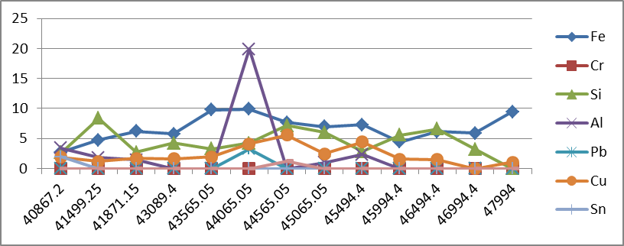

ppm

Total Running Hrs

ME (PdM) I/II

